CAPE VERDE ITINERARY (1 week)
Saturday
Home Island Sal Sunday
ROUTE: 09:00 LEAVING SAL - 00:00 ( midnight) Arrival in Sao Nicolau distance:
+ or - 92 nautical miles (about 15 hours sailing )
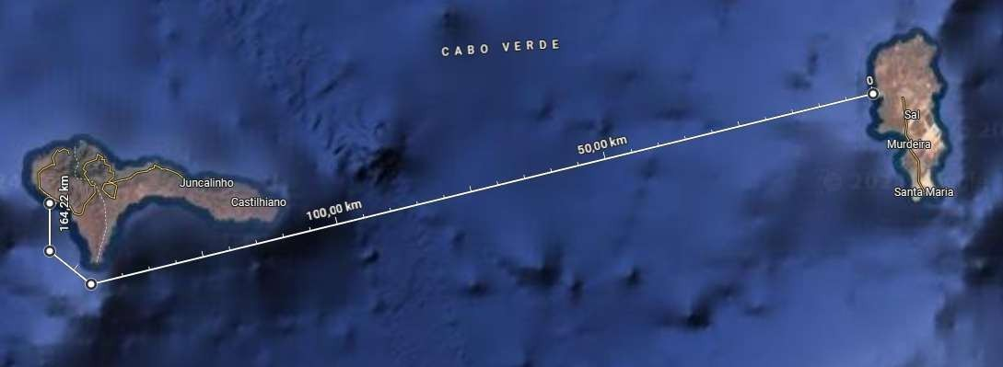
Monday
Tour in Sao Nicolau
Contact Ruslan, a Tourist Guide (+238 591 96 61 )
Tuesday
Route: 06:00 leaving Sao Nicolau - 17:00 arriving in Sao Vicente (Mindelo) Stop for lunch in Santa Luzia
Distance: + or - 60 nautical miles (about 10 hours sailing)
Attention! In the channel between Sao Vicente and Santo Antao the wind gets stronger.
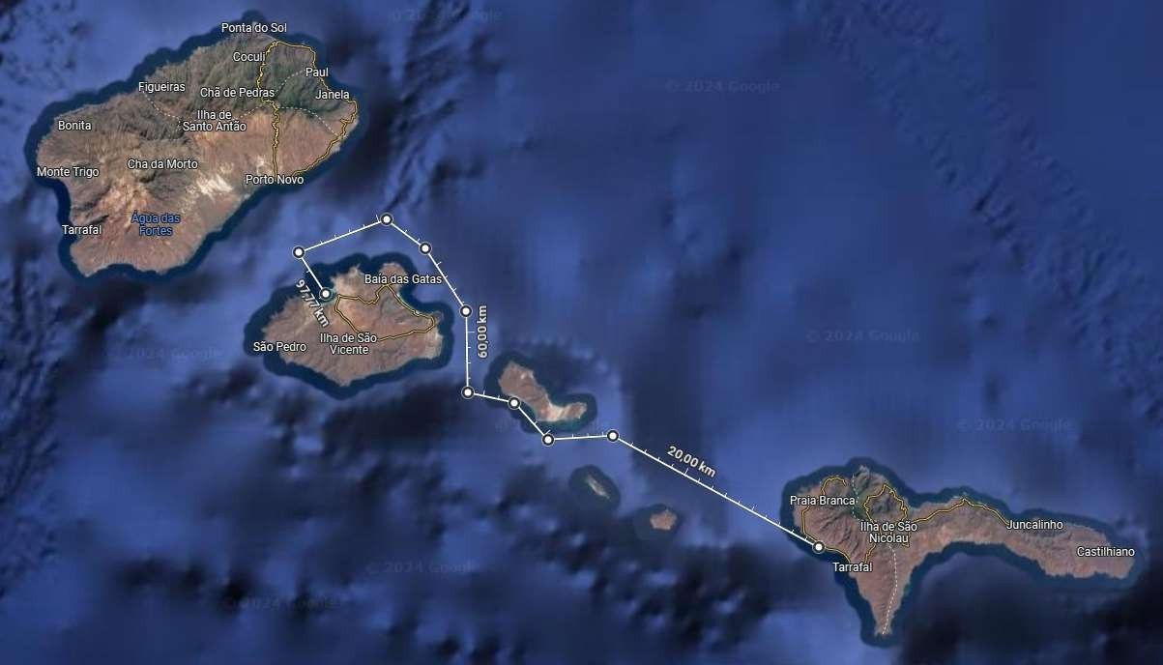

Wednesday
Route: 09:00 SAO VICENTE (MINDELO) - 09:00 (Thursday) Arrival in Boa Vista distance:
+ or - 144 nautical miles (about 24 hours sailing)
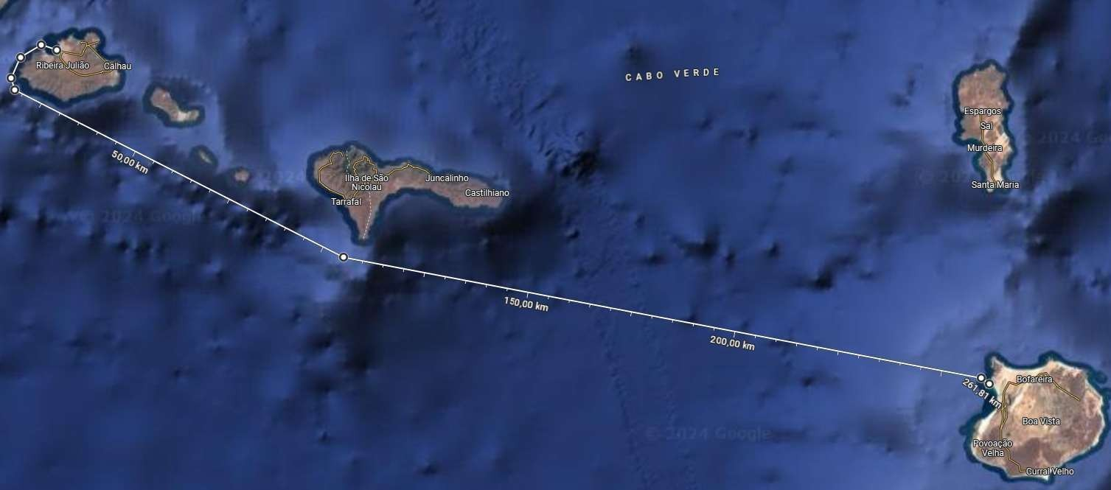
Thursday
Tour in Boa Vista
Contact Zelito Tour Guide (+238 5835273 )
Friday
Route: 06:00 Leaving Boa Vista - 16:00 Arriving in Sal for a swim in Santa Maria (if you have time)
Distance: + or - 60 nautical miles (about 10 hours browsing)
